Akeem Hutchinson
CSU Global MS AI and Machine Learning
CSC500 – Isaac Gang
Apr 19, 2026
https://github.com/akeemhutchinson-cmd/Module5.git

Pseudocode:
Calculate the total and average rainfall per month over a period of years
Assign variables
First loop will ask for number of years(x)
Secondary loop will iterate the amount of months for number of years
Within second loop ask for inches of rain fall
Calculate total rainfall and cumulative rainfall average
Print number of year and total months
Print total inches of rainfall
Print average rainfall per month for time span

Source code:
years = int(input ("How many years: "))
months = 12
total_rainfall = 0

for year in range(years):
for month in range(months):
m = float(input("inches of rain: "))
total_rainfall += m
cumaverage = total_rainfall / (years * months)

print ("Total months: ", months * years)
print ("total inches of rainfall: ",total_rainfall)
print (f"Average rainfall was {cumaverage} inches of rain over a {months * years} period")
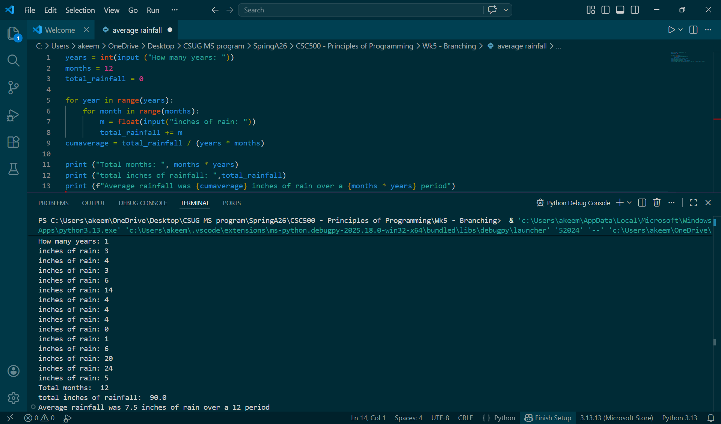

Pseudocode:
Create program to assign point values to amount of books bought per month
First establish loop for book count
Second assign point range
Within second loop allow for month to be input
Calculate total point value based on number of books purchased by student in a given month

Source code:
books_bought = int(input("How many books bought?: "))
book_point_mapping = {0:0, 2:5, 4:15, 6:30}

if books_bought >= 8:
print ("You scored 60 points!")

elif books_bought < 8 and books_bought % 2 == 0:
if books_bought in book_point_mapping:
print (f"You scored {book_point_mapping[books_bought]} points.")
else:
print ("You didn't score any points.")
